A Study of the Dark Side of AI: Adversarial Attacks on Deep Learning Systems and Defense Mechanisms

Gaurav Sharma , Dr.Sreevani Maddukuri
Gaurav Sharma (student), INT.Mtech CSE Spec. Cyber Security, VIT Bhopal Dr.Sreevani Maddukuri(supervisor), Dr. Hemraj .S.Lamkuche(reviewer 1),Puspinder Singh Patheja(reviewer 2), School of Computing Science Engineering and Artificial Intelligence, VIT Bhopal

ABSTRACT
Artificial Intelligence has significantly improved the capabilities of modern computing systems and is widely used in domains such as cybersecurity, healthcare, transportation, and finance. Despite these advantages, deep learning models remain vulnerable to adversarial attacks, where carefully crafted modifications to input data can cause incorrect predictions without obvious visual changes. Such vulnerabilities raise concerns regarding the reliability of AI systems in real-world applications.
This research investigates the security risks associated with adversarial attacks and evaluates a defense strategy based on adversarial training. A Convolutional Neural Network (CNN) was developed using the CIFAR-10 dataset and subjected to Fast Gradient Sign Method (FGSM) attacks under multiple perturbation levels. Experimental results showed a significant decline in model accuracy when adversarial examples were introduced, demonstrating the susceptibility of conventional deep learning models to manipulation.
To address this issue, adversarial training was incorporated into the learning process by exposing the model to both clean and adversarial samples. Comparative evaluation revealed that the adversarially trained model achieved improved robustness against FGSM attacks while maintaining acceptable classification performance. Additional analysis using robustness metrics, confusion matrix evaluation, and visual adversarial examples further validated the effectiveness of the proposed defense mechanism.
The findings highlight the importance of integrating security-focused techniques into AI development and contribute to ongoing efforts toward building trustworthy and resilient intelligent systems.

Introduction
Artificial Intelligence (AI) has transformed numerous domains, including healthcare, finance, transportation, education, and cybersecurity. The rapid advancement of machine learning and deep learning technologies has enabled intelligent systems to perform complex tasks with remarkable accuracy. These capabilities have accelerated the adoption of AI-powered solutions across both industrial and research environments. Despite its advantages, AI systems are vulnerable to various security threats that can compromise their reliability and trustworthiness. As AI becomes increasingly integrated into critical applications, attackers have developed sophisticated techniques to exploit weaknesses in machine learning models. These threats include data poisoning, model inversion, privacy leakage, deepfake generation, model theft, and adversarial

attacks. Such vulnerabilities represent the darker side of AI, where the same technology designed to solve problems can also be manipulated for malicious purposes.
Among these threats, adversarial attacks have emerged as one of the most significant challenges in deep learning security. Adversarial attacks involve introducing carefully crafted perturbations into input data with the objective of misleading a machine learning model. Although these perturbations are often imperceptible to humans, they can cause deep neural networks to produce incorrect predictions with high confidence. This vulnerability raises serious concerns regarding the deployment of AI systems in security-sensitive environments.
To better understand this challenge, this research focuses on evaluating the impact of adversarial attacks on image classification systems. A Convolutional Neural Network (CNN) was developed and trained using the CIFAR-10 dataset. The Fast Gradient Sign Method (FGSM), a widely used adversarial attack technique, was implemented to generate adversarial examples and assess model vulnerability under different perturbation strengths. In addition to analyzing attack effectiveness, this study investigates adversarial training as a defense mechanism for improving model robustness. The effectiveness of the proposed defense strategy is evaluated through comparative experiments involving standard classification accuracy, adversarial accuracy, multi-epsilon robustness analysis, confusion matrix evaluation, and visual demonstrations of adversarial examples.
The primary contributions of this work are as follows:
- Development of a CNN-based image classification model using the CIFAR-10 dataset. Implementation and evaluation of FGSM adversarial attacks under multiple perturbation levels.
- Investigation of adversarial training as a defense mechanism against adversarial attacks.
- Comparative analysis of standard and robust models using quantitative and visual evaluation metrics.
- Discussion of the security implications of adversarial attacks and the importance of robust AI systems.
The findings of this study contribute to the growing field of AI security by demonstrating both the vulnerabilities of deep learning models and the effectiveness of defensive strategies for mitigating adversarial threats.

Literature Review
Artificial Intelligence and deep learning technologies have achieved significant success in solving complex problems involving image recognition, natural language processing, recommendation systems, and cybersecurity applications. As the adoption of intelligent systems continues to increase, researchers have also identified several security challenges that threaten the reliability of machine learning models. Among these challenges, adversarial attacks have emerged as one of the most widely studied topics in AI security. Early research in adversarial machine learning demonstrated that deep neural networks can be highly sensitive to carefully designed input perturbations. These perturbations are often invisible to human observers but can significantly influence model predictions. Such findings revealed an important gap between human perception and machine learning decision-making, raising concerns regarding the deployment of AI systems in real-world environments. The Fast Gradient Sign Method (FGSM) introduced a practical approach for generating adversarial examples by utilizing gradient information from

the target model. Since its introduction, FGSM has become one of the most commonly used benchmark attacks for evaluating model robustness due to its simplicity and computational efficiency. Researchers have used FGSM extensively to study the behavior of neural networks under adversarial conditions and to measure the vulnerability of different architectures. Subsequent studies expanded this research area by developing stronger adversarial attack techniques capable of producing more effective perturbations. These investigations consistently demonstrated that even highly accurate neural networks could experience significant performance degradation when exposed to adversarial inputs. The results emphasized the necessity of designing defense mechanisms capable of improving model reliability in hostile environments. Among the proposed defense strategies, adversarial training has gained considerable attention. This approach introduces adversarial examples into the training process, allowing the model to learn more robust feature representations and decision boundaries. Numerous experimental studies have reported improvements in adversarial robustness when compared to conventionally trained models, although a tradeoff between clean accuracy and robustness is often observed. Among the proposed defense strategies, adversarial training has gained considerable attention. This approach introduces adversarial examples into the training process, allowing the model to learn more robust feature representations and decision boundaries. Numerous experimental studies have reported improvements in adversarial robustness when compared to conventionally trained models, although a tradeoff between clean accuracy and robustness is often observed. In addition to adversarial attacks, researchers have explored other security threats associated with artificial intelligence, including data poisoning, model extraction, model inversion, privacy leakage, and deepfake generation. These threats demonstrate that AI systems face risks throughout the entire machine learning lifecycle, from data collection and model training to deployment and inference. Consequently, security has become a critical consideration in the development of trustworthy AI systems. While previous studies have established the existence of adversarial vulnerabilities and proposed various defense mechanisms, practical implementations remain valuable for understanding the real-world impact of such attacks. This research contributes to the field by experimentally evaluating FGSM attacks against a CNN-based image classification model and assessing the effectiveness of adversarial training using the CIFAR-10 dataset. Through quantitative evaluation, robustness analysis, confusion matrix assessment, and visual adversarial demonstrations, the study provides practical evidence of both model vulnerability and defense effectiveness.
.

Methodology
This research investigates the vulnerability of deep learning models to adversarial attacks and evaluates the effectiveness of adversarial training as a defense mechanism. The overall methodology consists of dataset preparation, CNN model development, adversarial attack generation, adversarial training, and robustness evaluation.

Dataset
The CIFAR-10 dataset was used for all experiments. CIFAR-10 is a widely used benchmark dataset for image classification tasks and contains 60,000 color images of size 32×32 pixels distributed across 10 classes. The dataset is divided into 50,000 training images and 10,000 testing images.
The ten classes included in the dataset are:
* Airplane
* Automobile

* Bird
* Cat
* Deer
* Dog
* Frog
* Horse
* Ship
* Truck
The dataset was loaded using the PyTorch framework and transformed into tensor format before training and evaluation.

Convolutional Neural Network Architecture
A Convolutional Neural Network (CNN) was implemented as the baseline image classification model. The architecture consists of two convolutional layers followed by a max-pooling operation and two fully connected layers.
The model architecture is summarized below:
- Convolution Layer 1: 3 input channels, 32 output channels, kernel size 3×3.
- Convolution Layer 2: 32 input channels, 64 output channels, kernel size 3×3.
- Max Pooling Layer: Pool size 2×2.
- Fully Connected Layer 1: 4096 input features and 512 output features.
- Fully Connected Layer 2: 512 input features and 10 output classes.
The network was trained using the Adam optimizer with a learning rate of 0.001 and Cross Entropy Loss as the objective function.

Fast Gradient Sign Method (FGSM)
To evaluate model vulnerability, the Fast Gradient Sign Method (FGSM) was implemented. FGSM generates adversarial examples by adding perturbations in the direction of the gradient of the loss function with respect to the input image.
The perturbation is calculated as: FGSM(x) = x + ε · sign(∇x J(θ, x, y)) where:
* x represents the original image.
* ε represents the perturbation strength.

* J represents the loss function.
* θ represents model parameters.
* y represents the true label.
Multiple perturbation strengths were evaluated to analyze attack effectiveness under varying threat levels

Adversarial Training
To improve robustness against adversarial attacks, adversarial training was employed. During training, adversarial examples generated using FGSM were incorporated into the learning process.The adversarial trained model was exposed to both clean and adversarial samples, enabling the network to learn more robust feature representations and decision boundaries. Comparative experiments were performed to evaluate the effectiveness of adversarial training relative to the baseline CNN model.

Evaluation Metrics
The performance of the proposed system was evaluated using the following metrics:
- Classification Accuracy
- Adversarial Accuracy
- Multi-Epsilon Robustness Analysis
- Confusion Matrix Evaluation
- Visual Analysis of Adversarial Examples
These metrics provide both quantitative and qualitative insights into model performance, vulnerability, and robustness under adversarial conditions.

Experimental Setup
  - Development Environment
All experiments were conducted using Python and the PyTorch deep learning framework. The implementation was developed and executed in Visual Studio Code on a Windows-based system. Model training, adversarial attack generation, robustness evaluation, and result visualization were performed within a virtual Python environment.
The primary software components used in this research include:
* Python 3.x
* PyTorch
* Torchvision
* Matplotlib

* NumPy
* Scikit-learn

Dataset Configuration
The CIFAR-10 dataset was automatically downloaded using Torchvision. The dataset consists of 50,000 training images and 10,000 testing images distributed across ten object categories.
Images were converted into tensor format before being supplied to the neural network.

CNN Training Configuration
The baseline CNN model was trained using the following parameters:

Parameter | Value
Optimizer | Adam
Learning Rate | 0.001
Loss Function | Cross Entropy Loss
Batch Size | 32
Dataset | CIFAR-10
Training Images | 50,000
Testing Images | 10,000

The baseline model achieved a classification accuracy of 72.54% on the CIFAR-10 test dataset.

FGSM Attack Configuration
The Fast Gradient Sign Method (FGSM) was used to generate adversarial examples and evaluate model robustness.
The following perturbation strengths were evaluated: Epsilon Value
0.01, 0.03 ,0.05,0.10

These values were selected to observe the effect of increasing perturbation strength on classification accuracy.Adversarial Training Configuration
To improve model robustness, adversarial training was performed using FGSM-generated adversarial examples.
The final robust model was trained using:

Parameter | Value
Adversarial Attack | FGSM
Training Epsilon | 0.03
Epochs | 10
Optimizer | Adam
Learning Rate | 0.001
Loss Function | Combined Clean And Adversarial Loss

The adversarial trained model was evaluated using the same test dataset and attack configurations to enable fair comparison with the baseline CNN model.

Generated Artifacts
Several artifacts were generated during experimentation for analysis and visualization:
* Epoch Accuracy Graph
* FGSM Accuracy Comparison Graph
* Multi-Epsilon Robustness Graph
* Adversarial Example Visualization
* Robust Adversarial Example Visualization
* Confusion Matrix
These artifacts provide both numerical and visual evidence of model behavior under adversarial conditions.

Results and Discussion
  - Baseline CNN Performance
The CNN model was initially trained and evaluated on the CIFAR-10 dataset to establish a baseline performance benchmark.

The model achieved a test accuracy of:

72.54%
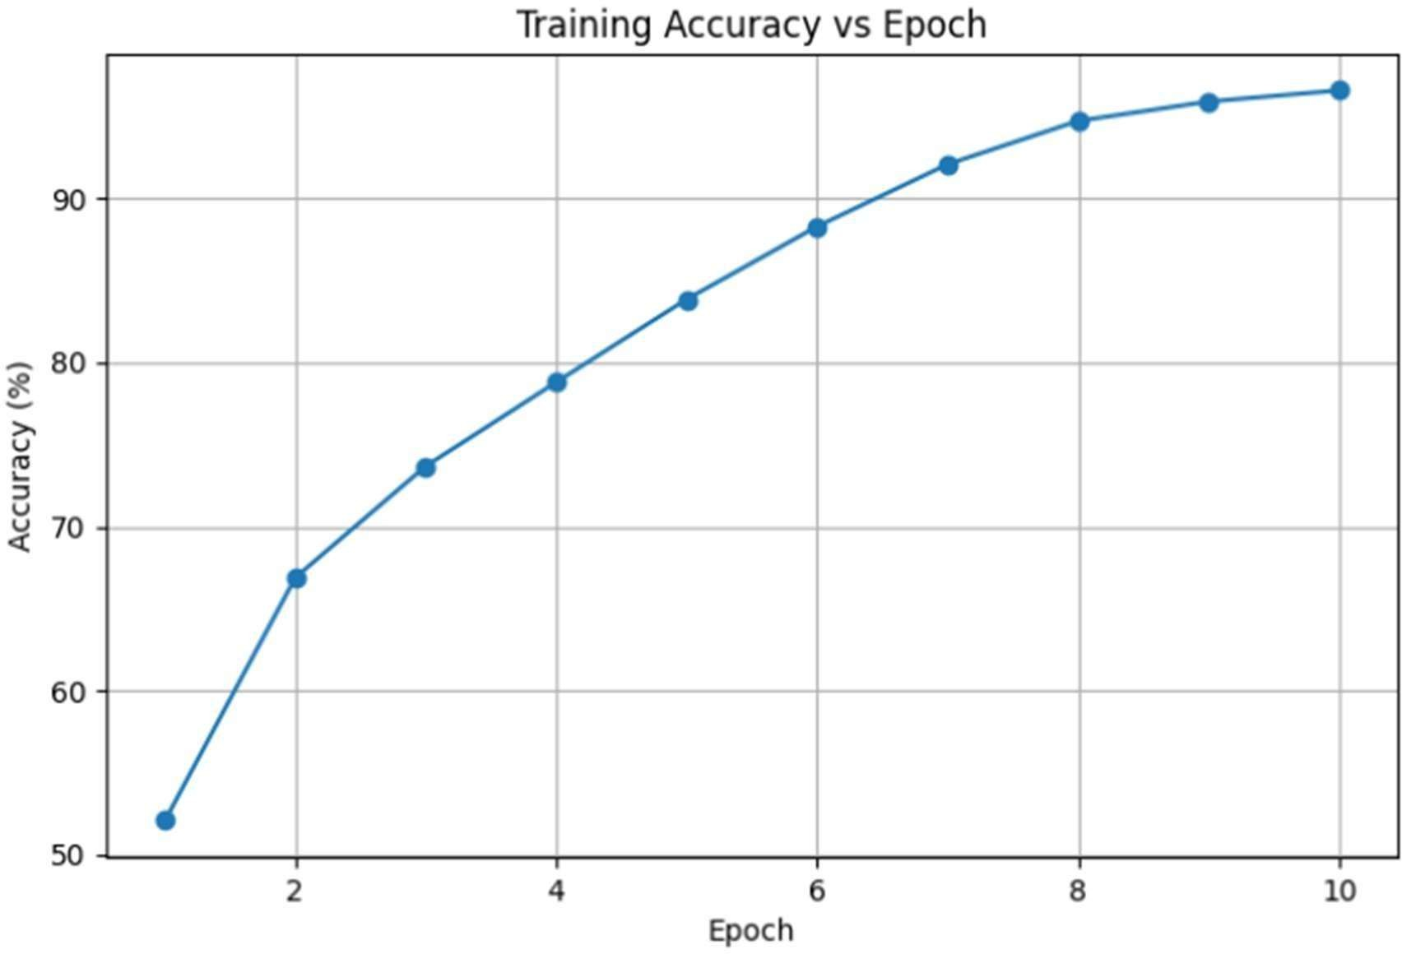
Figure 1. Training Accuracy of CNN Across Training Epochs
This result demonstrates that the CNN was capable of learning meaningful image representations from the dataset and provided a suitable baseline for adversarial attack analysis.

Impact of FGSM Adversarial Attacks
To evaluate model vulnerability, FGSM adversarial attacks were performed using multiple perturbation strengths.
The classification accuracy of the baseline CNN under adversarial conditions is shown below.

Epsilon | Accuracy(%)
0.01 | 23.13
0.03 | 7.34
0.05 | 3.35
0.10 | 1.04
The results indicate a significant degradation in classification performance as the perturbation strength increased. Even a relatively small perturbation value of 0.03 reduced model accuracy from 72.54% to 7.34%, demonstrating the vulnerability of deep learning models to adversarial

manipulation.

Adversarial Example Analysis
Visual inspection of adversarial examples revealed that the generated perturbations were difficult to distinguish from the original images. Despite minimal visual differences, the CNN frequently produced incorrect predictions.
In one experimental example:
* Original Prediction = 3
* Adversarial Prediction = 5
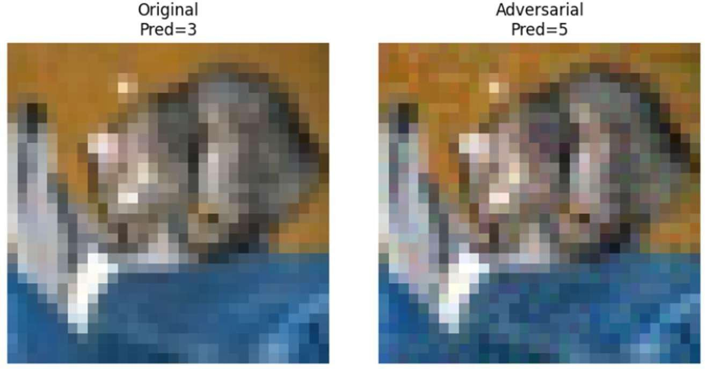
Figure 4. Successful FGSM Attack Causing Prediction Change
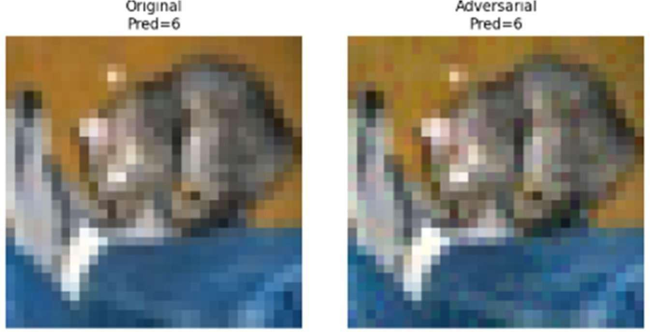
Figure 5. Robust CNN Preserving Prediction Under FGSM Attack
The results demonstrate that adversarial perturbations can successfully mislead a standard CNN model. In contrast, the adversarial trained model-maintained prediction consistency under similar perturbations, indicating improved robustness against FGSM attacks.
This observation confirms that adversarial perturbations can successfully mislead deep learning models without introducing obvious visual distortions.

Adversarial Training Performance

To improve robustness, adversarial training was implemented. The final adversarial trained model achieved:

65.15% Classification Accuracy
Although the accuracy was lower than the baseline CNN, the model demonstrated substantially improved resistance to adversarial attacks.
This result highlights the tradeoff between classification accuracy and robustness that is commonly observed in adversarial machine learning.

Robustness Evaluation of the Adversarial Trained Model
The robust model was evaluated using the same FGSM attack strengths. Table 2. Robust Model Accuracy Under FGSM Attack

Epsilon | Robust Accuracy (%)
0.01 | 49.87
0.03 | 28.38
0.05 | 16.09
0.10 | 4.63

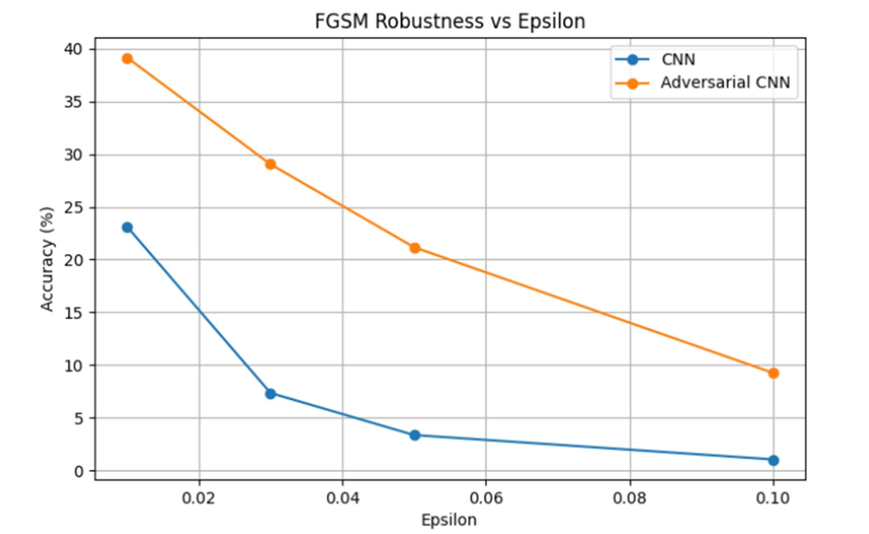
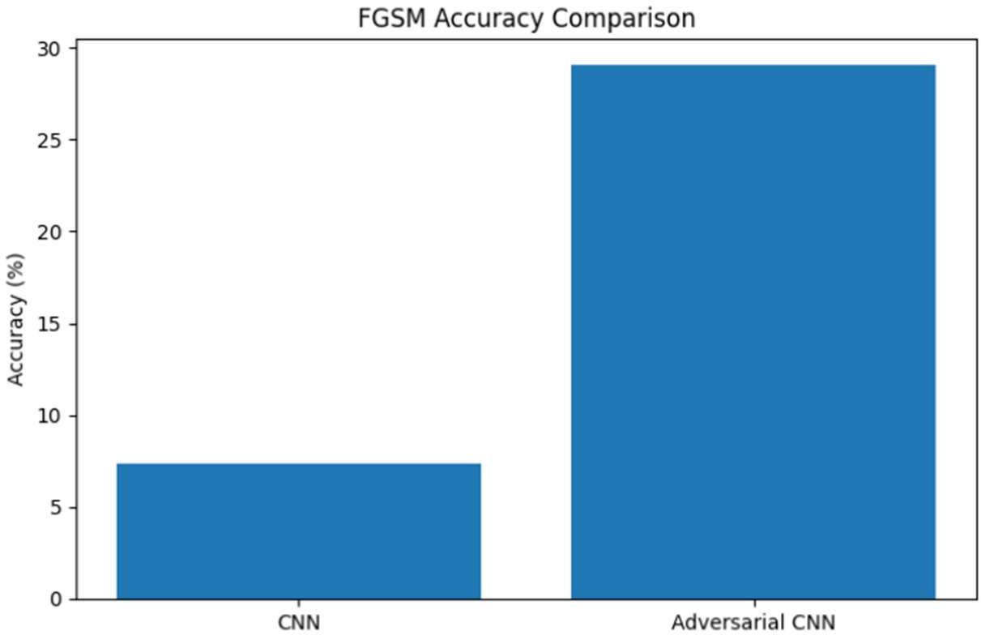
5.5 Robustness Evaluation of the Adversarially Trained Model The robust model was evaluated using the same FGSM attack strengths

Figure 6. FGSM Accuracy Comparison Between Standard CNN and Adversarial Trained CNN.
Compared with the baseline CNN, the adversarial trained model retained significantly higher accuracy under attack conditions.

For example: * Baseline CNN at ε = 0.03 → 7.34%
* Robust CNN at ε = 0.03 → 28.38%
This demonstrates the effectiveness of adversarial training in improving model resilience

Metric | Standard CNN | Robust CNN
Clean Accuracy | 72.54% | 65.15%
FGSM Accuracy (ε=0.03) | 7.32% | 28.38%

Comparison Between Standard and Robust Models
The robust model sacrificed a portion of clean accuracy in exchange for significantly improved adversarial robustness. This tradeoff is consistent with observations reported in existing adversarial machine learning literature.

Confusion Matrix Analysis

A confusion matrix was generated to analyze class-level prediction behavior.
The confusion matrix revealed that certain visually similar classes were more likely to be misclassified than others. Such observations provide insight into the strengths and limitations of the CNN architecture when applied to complex image classification tasks.
The confusion matrix further supports the quantitative evaluation results by highlighting specific categories that contribute to overall classification errors.
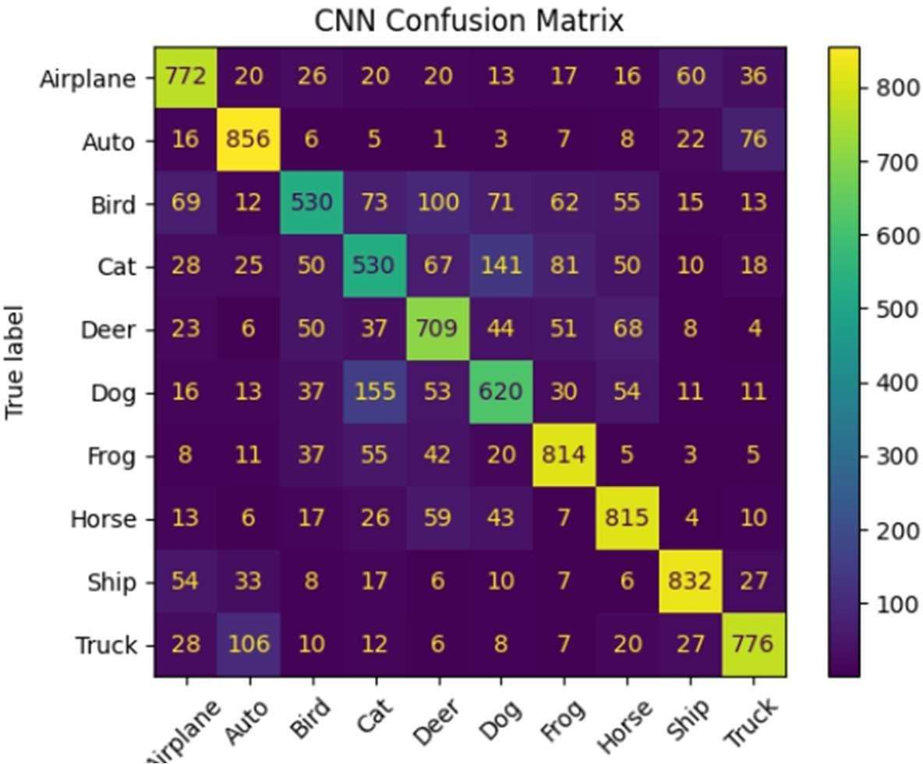
Figure 7. Confusion Matrix of CNN Classification Results

Discussion
The experimental results clearly demonstrate the security risks posed by adversarial attacks in deep learning systems. A highly accurate CNN model became extremely vulnerable when exposed to adversarial perturbations generated using FGSM.
The study further demonstrated that adversarial training can substantially improve model robustness against adversarial examples. Although some reduction in clean accuracy was observed, the adversarial trained model maintained significantly better performance under attack conditions.
These findings emphasize the importance of incorporating security-focused defense mechanisms into AI systems, particularly when deploying machine learning models in security-critical environments such as cybersecurity, autonomous systems, healthcare, and financial applications.

Limitations of the Study
Although the proposed adversarial training approach improved robustness against FGSM attacks, several limitations remain. The experiments were conducted using a relatively simple CNN architecture and a single benchmark dataset (CIFAR-10). Additionally, the defense mechanism was evaluated primarily against FGSM attacks and may exhibit different performance against stronger adversarial attack methods such as PGD or Deep Fool. Future research should investigate more advanced architectures, larger datasets, and multiple attack strategies to provide a broader assessment of model robustness.

Conclusion
Artificial Intelligence has become an essential component of modern computing systems; however, its growing adoption has also introduced new security challenges. Among these challenges, adversarial attacks represent a significant threat to the reliability and trustworthiness of deep learning models. This research investigated the vulnerability of a Convolutional Neural Network (CNN) trained on the CIFAR-10 dataset when subjected to adversarial perturbations generated using the Fast Gradient Sign Method (FGSM). Experimental results demonstrated that the baseline CNN experienced a substantial decline in classification accuracy under adversarial conditions, highlighting the effectiveness of adversarial attacks against deep learning systems. To mitigate these vulnerabilities, adversarial training was implemented as a defense mechanism. Comparative analysis showed that the adversarially trained model achieved significantly improved robustness against FGSM attacks while maintaining competitive classification performance. Multi-epsilon evaluation, confusion matrix analysis, and visual adversarial examples further validated the effectiveness of the proposed defense strategy.
The findings of this study reinforce the importance of incorporating security-oriented design principles into AI systems and demonstrate that adversarial training can serve as an effective approach for improving model resilience against adversarial threats.security-critical environments such as cybersecurity, autonomous systems, healthcare, and financial applications.

8.Future Work
Although the proposed defense mechanism improved robustness against FGSM attacks, several

opportunities remain for future research.
Future work may include Evaluation of additional adversarial attack techniques such as Projected Gradient Descent (PGD), DeepFool, and Carlini-Wagner attacks.
- Investigation of advanced defense mechanisms including robust optimization and certified defenses.
- Application of adversarial training to deeper neural network architectures. 3.Evaluation of robustness on larger and more complex datasets.
4.Exploration of adversarial threats in domains such as cybersecurity, autonomous systems, healthcare, and privacy-preserving AI.
These directions can further contribute to the development of secure, trustworthy, and resilient artificial intelligence systems.

9.References
- I. J. Goodfellow, J. Shlens, and C. Szegedy, “Explaining and Harnessing Adversarial Examples,” International Conference on Learning Representations (ICLR), 2015.
- A. Krizhevsky, “Learning Multiple Layers of Features from Tiny Images,” University of Toronto, Technical Report, 2009.
- Y. LeCun, Y. Bengio, and G. Hinton, “Deep Learning,” Nature, vol. 521, no. 7553, pp. 436– 444, 2015.
- N. Papernot et al., “Practical Black-Box Attacks against Machine Learning,” ACM Asia Conference on Computer and Communications Security, 2017.
- A. Madry et al., “Towards Deep Learning Models Resistant to Adversarial Attacks,” International Conference on Learning Representations (ICLR), 2018

